LAB 14: Using JFLAP creating SLR (1) parse table for a given grammar. Simulate parsing and output the parse tree proper format.

Input CFG

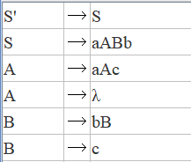

First and Follow with Parse Table

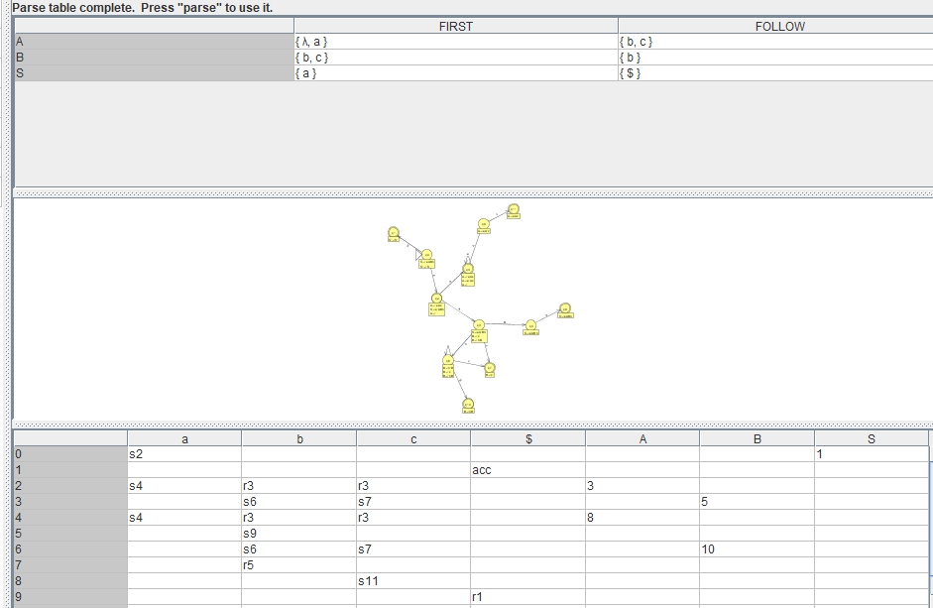



None inverted parse tree

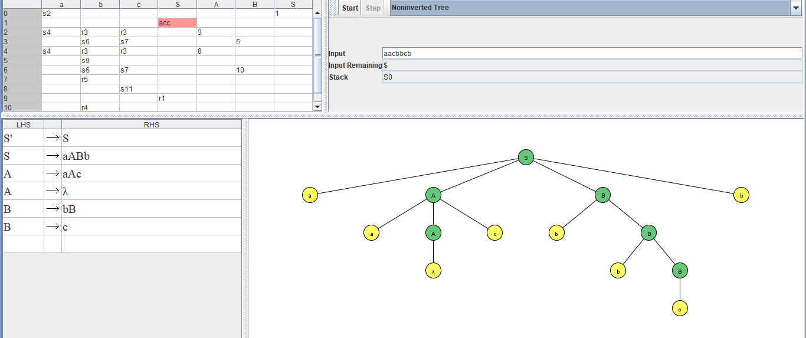

Input is accepted as there is only $remaining